Lab 1 : Application Problem

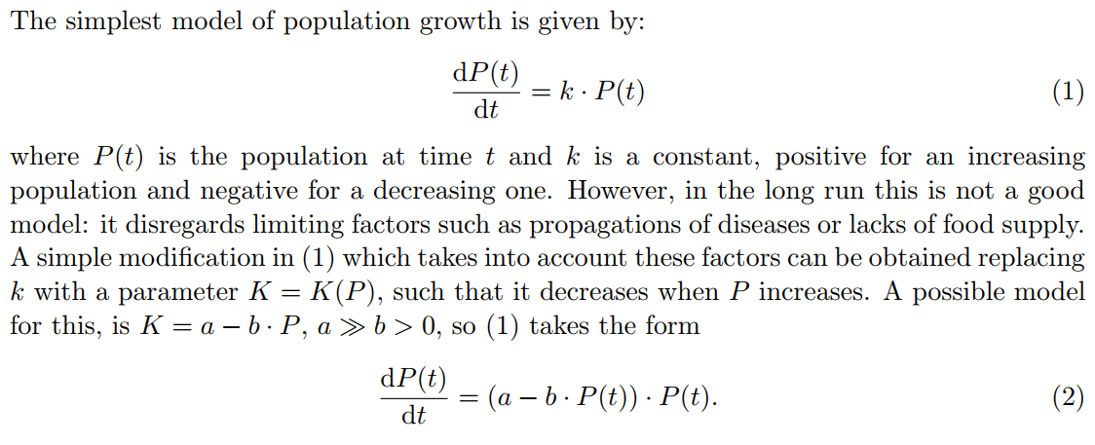

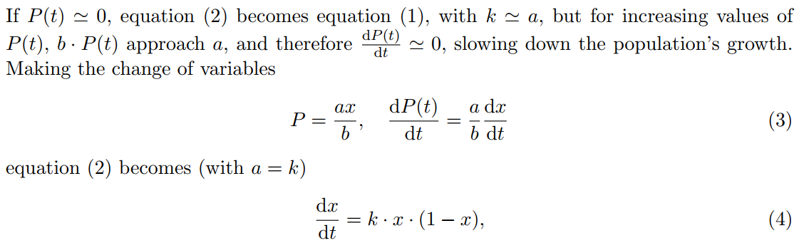

Use Maxima to solve equation (4). Set the initial condition for equation (4) as x( t = 0 ) = x0;

Find the explicit solution of the particular solution obtained using the given initial condition of the equation (4).

Use wxplot2d to display the graphs of particular solution for various k ranging from 0.25 to 1.75 whenever x0 is 0.1.